MUNA (MODEL UNITED NATIONS ASSEMBLY)
22-23 May 2020
“MUNA was amazing and changed my life. After MUNA I was so inspired that instead of following science as a career, I went on to do international politics.” Past attendee.
Purpose:
- To simulate the working of the United Nations Assembly by having school teams of three, Year 12 and 13 (Forms 6 and 7) students representing a particular UN country in debates on matters of world politics and social concern.
- Debates are held from Friday morning until Saturday afternoon.
Goals:
- To develop in students an awareness of the United Nations and the international situation of the countries of the world.
- To enable students to improve their public speaking and debating skills.
- To encourage students to make informed comments on world problems.
- To encourage students to share their opinions and friendship with students from other schools in Districts 9910 & 9920.
Venue: Auckland Girls Grammar School, Howe Street, Freemans Bay
Club Planning:
February Secondary Schools are sent entry forms from Auckland Girls Grammar School. (Clubs are also advised.) Clubs should follow up with their affiliated secondary schools and encourage a team(s) to participate.
Agree and advise the amount of club contribution.
March Entry forms returned to Auckland Girls Grammar School by participating schools. Rotary Club of Auckland East contacts the sponsoring club to determine the level of their sponsorship for invoicing.
April Invoices will be sent by Rotary Club of Auckland East to the school and that school's sponsoring Rotary Club. (Entries close 3 April 2020)
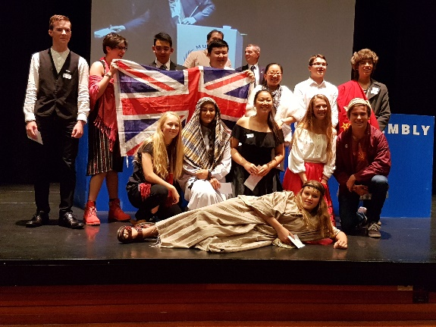
Costs $250 per team of 3 students usually split Rotary Club $150-and the school $100-for the first team.
Second and subsequent teams are usually paid for by the school at $250-.
However, some clubs historically have paid all or part of the entry fee for further teams.
Your club need agree the amounts with the school.

MUNA Co-ordinator (District 9910/9920)
Ian Willetts Rotary Club of Auckland East
Email: ianmwilletts@xtra.co.nz
Mobile: 021 811 822

