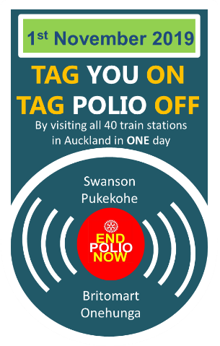
Name:

Rotary Club:

Help me contribute to the Global Polio Eradication Campaign and sponsor me as I ride the Auckland train network on Friday 1 November 2019 as part of Rotary’s fundraising event to #tagpoliooff.
There are 40 stations in total and my aim is to visit as many as possible between 8am and 6pm.
You are welcome to be part of the fun and join in.
Contact me to find out more

SPONSOR  NAME | SPONSOR CONTACT | PLEDGE AMOUNT PER STATION | FINAL AMOUNT

