DISTRICT 9920 FOUNDATION NEWS
MAY 2021 – BULLETIN NO. 21

Message from our District Foundation Chair PDG Jennie Herring
It is hard to believe that we are now in May 2021 with only just under two months to go before we enter the Rotary 2021/2022 year.
Despite the Covid 19 pandemic the D9920 Rotary Foundation has
continued to support clubs in all their efforts ‘to do good in the world’.
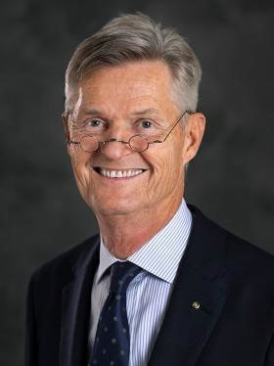
This year we have supported the following:

Give Every Child A Future (GECAF) which is now in its second year providing vaccinations to the children of nine Pacific Island Nations including Kiribati, Tonga, Samoa, Cook Islands. The vaccines are: HPV - 2 doses per girl Rotavirus - 2 doses per child
Pneumococcal Conjugate - 3 doses per child.

The Kiribati Sanitation Project - three toilets/shower blocks to three Community Groups in South Tarawa.
Taveuni Eye Project
IT Social Enterprise Madagascar
Bangladesh Family Health Days

RI President Holger Knaack
Bordya Wala Dam – India
Strengthening Education Venezuelan Refugees
E Club Covid 19 projects in Brazil, India, Soeng Sang
E Club Japur Limb Workshop
Plus $32157.00 in District Grants
The committee has also agreed to donation $5000 DDF
To the End Polio Programme

In 2021/2022 we have already pledged DDF to GECAF
(Year 3) and to a Global Grant supporting a Wanganui Surgeon to Tonga.
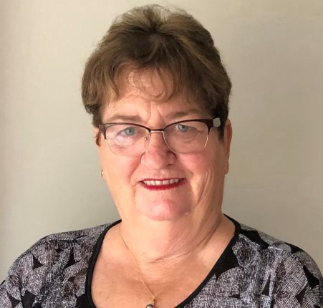
None of the above can be achieved without Clubs supporting the Foundation Annual Giving programme. Despite several attempts requesting Clubs to forward their Annual Giving this has not been successful.
DG Craig Horrocks
The District is still just over 50% of the monies raised in the 2019/2020 year. What does this mean. Its means that in 2023/2024 our District will receive very little return to support Clubs wishing to participate in District and Global Grants.

I would ask all Club Presidents who have not already contributed to the Annual Giving to please do so by 14 May 2021 at the latest as Foundation donations for 2020/2021 close off on 31 May 2021.

Yours in Rotary Service
DRFC – PDG Herring
Jennie Herring – D9920 DRFC

END POLIO NOW

POLIO ALL TRANSIT 2021
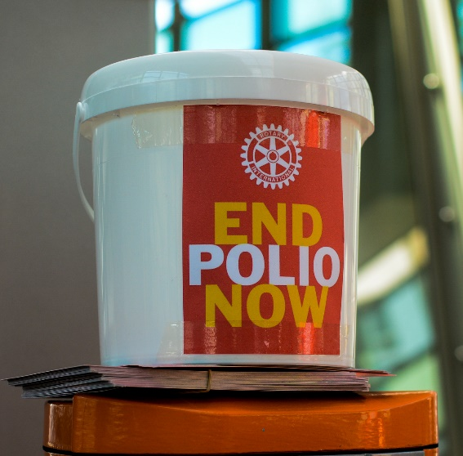
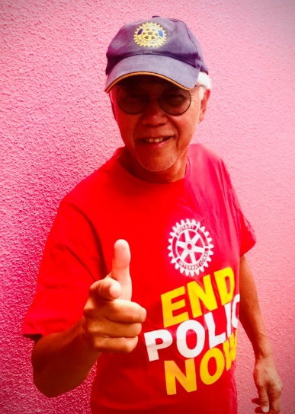

The “sea of red” came to the Auckland Rail and Ferry network last Friday 23 October 2020. The event Polio All Transit, an Auckland Rotary project, was a repeat of the 2019 inaugural Polio All Trains event promoting End Polio Awareness. This involved riders meeting groups of Rotarians and friends at train stations and ferries raising $37,000 .This amount with support from the Bill & Melinda Gates Foundation multiplier becomes 3 times that amount or $91,000 to go towards the global End Polio campaign.

Billed by “Mr Polio” PDG Ron Seeto to be Bigger Bolder and Better last year’s event included a send off by the Mayor of Auckland Hon. Phil Goff who was at Britomart to welcome, congratulate and see off the first riders on the 8:12am train to Swanson. Other well known faces there in support and ride a few stops were Members of Parliarment David Seymour (whose mother is a Polio survivor), Simeon Brown, Chris Luxon and councilllor Paul Young alongside Miss New Zealand beauty contestants.

Chair of the Polio All Transit event Ron hopes to see this event grow each year as
community understanding of viruses has grown through the COVID 19 experience.
Polio is a virus and whilst eradicated from New Zealand, remains borderless and
is only a plane ride away.

Watch this space for Polio All Transit 2021 pencilled for Friday 29 October 2021.

For more information:
https://www.rotarydistrict9920.org/Stories/success-polio-all-transit-a-huge-success

PDG RON SEETO (D9920 Mr Polio)

CLUB MAJOR DONORS

The Rotary Foundation has announced two new programs under the title of Recognising Clubs That Support the Foundation:

- Club Annual Donor - for giving during the past 12 months
  - Achievable by all clubs: including new and small clubs (it is per member)

- Club Major Donor - Recognising our largest supporters
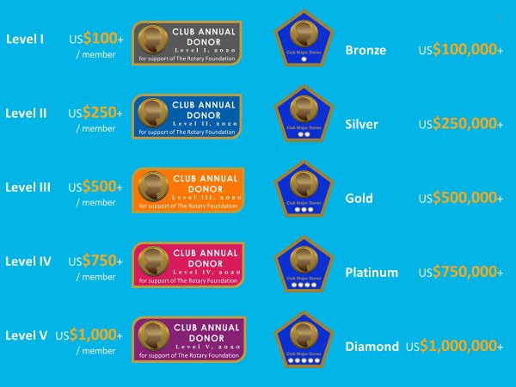
  - Once earned – it is yours forever

These two new initiatives are for contributions from the Club not from the members and others.

All contributions to the Annual Fund, PolioPlus, Global Grants, Endowment and Disaster fund are donations that are counted in this calculation.

SITUATION VACANT

Foundation Committee Secretary

Our current Secretary Kathryn Harvey (Somerville Club)
has agreed to take on the position of Foundation Treasurer/Administrator commencing 1 July 2021
If anyone is interested in joining our committee by taking up
the position of Committee Secretary please contact me on
027 2932095. This is a great way for Rotarians to
learn more about how our Foundation works.

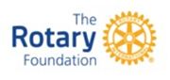

TRF – SEVEN AREAS OF FOCUS

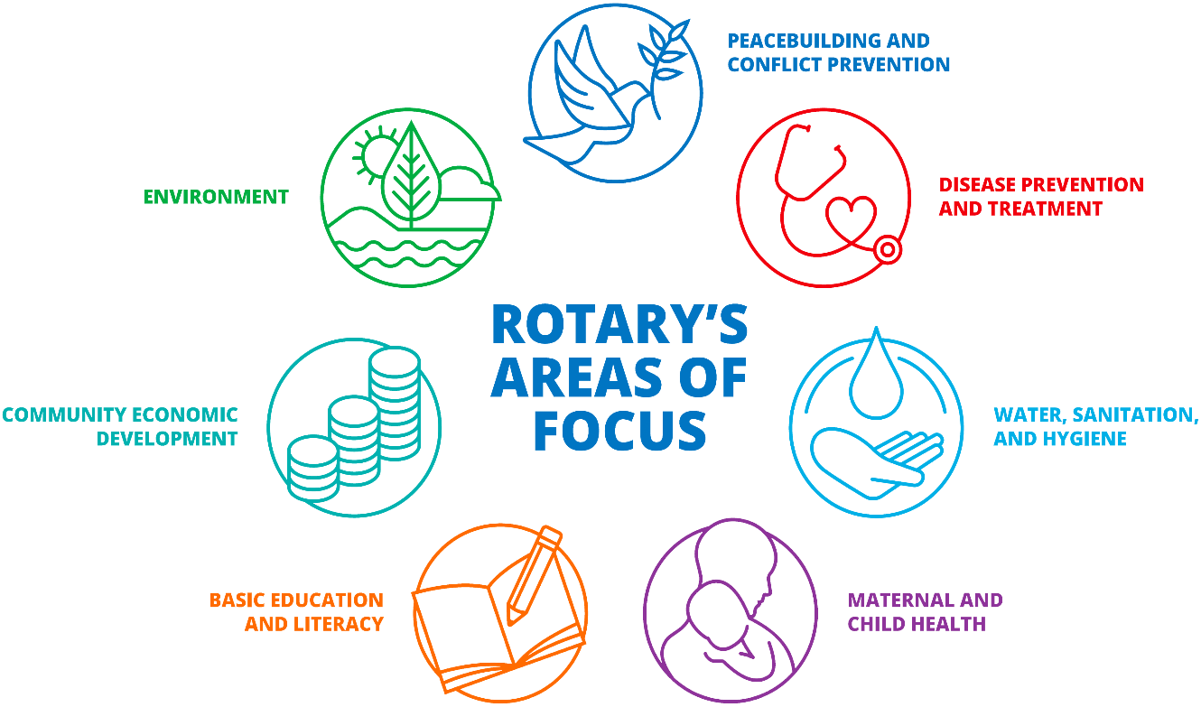

As of 1 July 2021 the Rotary Foundation will be accepting Global
Grant applications for its new and seventh area of focus – the
Environment.

If your Club is intending on submitting an application in regard to an
Environmental Project please contact Jennie Herring (Chair) or Richard
Thorpe (Global Grants Chair) so that we are informed and can plan accordingly.

DONORS
DONATIONS AND CONTRIBUTIONS TO D9920 ROTARY FOUNDATION
ROTARY INTERNATIONAL

District 9920 Rotary Foundation Committee

Donations and Contributions to Rotary Foundation.
District 9920

New Zealand based Clubs
The New Zealand based Rotary Clubs can sent their donation and contribution for Annual Giving and Polio Plus by internet to the Rotary Foundation Administrator 9920, stating what the amount is for, donating through the club or charitable trust. Tax receipts are forwarded in August/September.

New Zealand Rotarians
Most if not all clubs have a Charitable trust. The Rotarians should donate through their club’s charitable trust, who can issue individual Tax Donation Receipt. The Club’s charitable trust can then forward this total amount on to Rotary Foundation Administrator 9920. The Club or Charitable trust should email an Excel sheet with the Rotarian’s name, ID number and Amount. This can be allocated under the Rotarian’s name and credited with RI to credit
Rotarians with the Tax Donation Receipt can claim the lessor of 33% of the donation on your taxable income.

Donations Paul Harris Society (PHS) Members and Sustaining Members.
These donations should be paid directly to Rotary Foundation Administrator 9920. Tax receipts are forwarded in April/May

Global Payment System
Individual Rotarians can make a Donation directly to Rotary Foundation through the RI website. Using your access user name and password will help you through it. The Administrator is advised and is credited to your club.
Please Note: Unfortunately the donation through this scheme is not New Zealand Tax deductible.

Internet Banking
Clubs or Individual Rotarians can pay through Internet banking.
Bank Account “Rotary Foundation 9920”
02 0256 0333474 00, Reference box “Club name “. Please email pdmwilcock@gmail.com the amount and the allocation i.e. Annual Giving or Polio and club name.
Please ensure that we have your email address to send the receipt to.

Payment by Cheque
Please Note: Do not use cheques as it is very difficult to deposit them at the Bank, especially during this pandemic, please use the internet banking, much safer and reliable.

Peter Wilcock
Rotary Foundation Administrator District 9920
Mob 027 285 1763

Note. The donations are transferred to RI Parramatta before the15th of the month, any donations after that are at the Rotary exchange rate for the next month. The Rotary year closes for Donations on 31 May.

FOUNDATION COMMITTEE 2020/2021

Foundation Committee Chair | PDG Jennie Herring | 027 293 2095 | herringjennie@gmail.com
Global Grants | Richard Thorpe | 021 289 7744 | richma@xtra.co.nz
Global Grant Administration | Allan Mckay | 027 518,2309 | allan.loismckay@gmail.com
Stewardship (Club qualification) | PDG Willard Martin | 029 576 6437 | 4kiwimartins@gmail.com
Foundation Fund Administrator/Foundation Treasurer | Peter Wilcock | 027 285 1763 | pdmwilcock@gmail.com
Committee Secretary | Kathryn Harvey | 029 576 2792 | Kathryn@kjhbusiness.co.nz
Chair - End Polio Advocacy & Fund Raising | PDG Ron Seeto | 027 459 3282 | ronseeto@ronseetoarchitect.co.nz
Ambassadorial Scholarships | Shefali Mehta | 021 941 181 | shefalim@pdl123.co.nz
Peace Scholarships | Byran Theunisen | 027 579 7930 | btheunisen@kpmg.co.nz
Public Relations | Madison Chang | 027 5105138 | p3pmadison@hotmail.com
Fundraising - Endowment &  Major Gifts PHS | DG Gary Langford | 021 923 901 | glangford.rotary@gmail.com
Pacific Liaison Committee | PDG Malini Raghwan | 00679 999 3541 | mraghwan@gmail.com
District Governor ex officio | Craig Horrocks
District Governor Elect Ex Officio | Steve Chaney
District Governor Nominee Ex Officio | Allan Smith

